Cairo University Faculty of Computers and Artificial Intelligence



**Software design specification document**

**2022**

|  |  |  |
| --- | --- | --- |
| **ID** | **Name** | **Email** |
| 20200498 | Mahmoud Sayed Ashore | mahmoudsayed1332002@gmail.com |
| 20201203 | Nourhan Amr Abdelwahab Fathy | noramr318@gmail.com |
| 20201041 | Aya Hasanin Sayed AbdElmageed | ayaayad162002@gmail.com |
| 20190109 | Omnia Magdy Othman Ahmed | Omniamagdi21@gmail.com |

**Class Diagram**

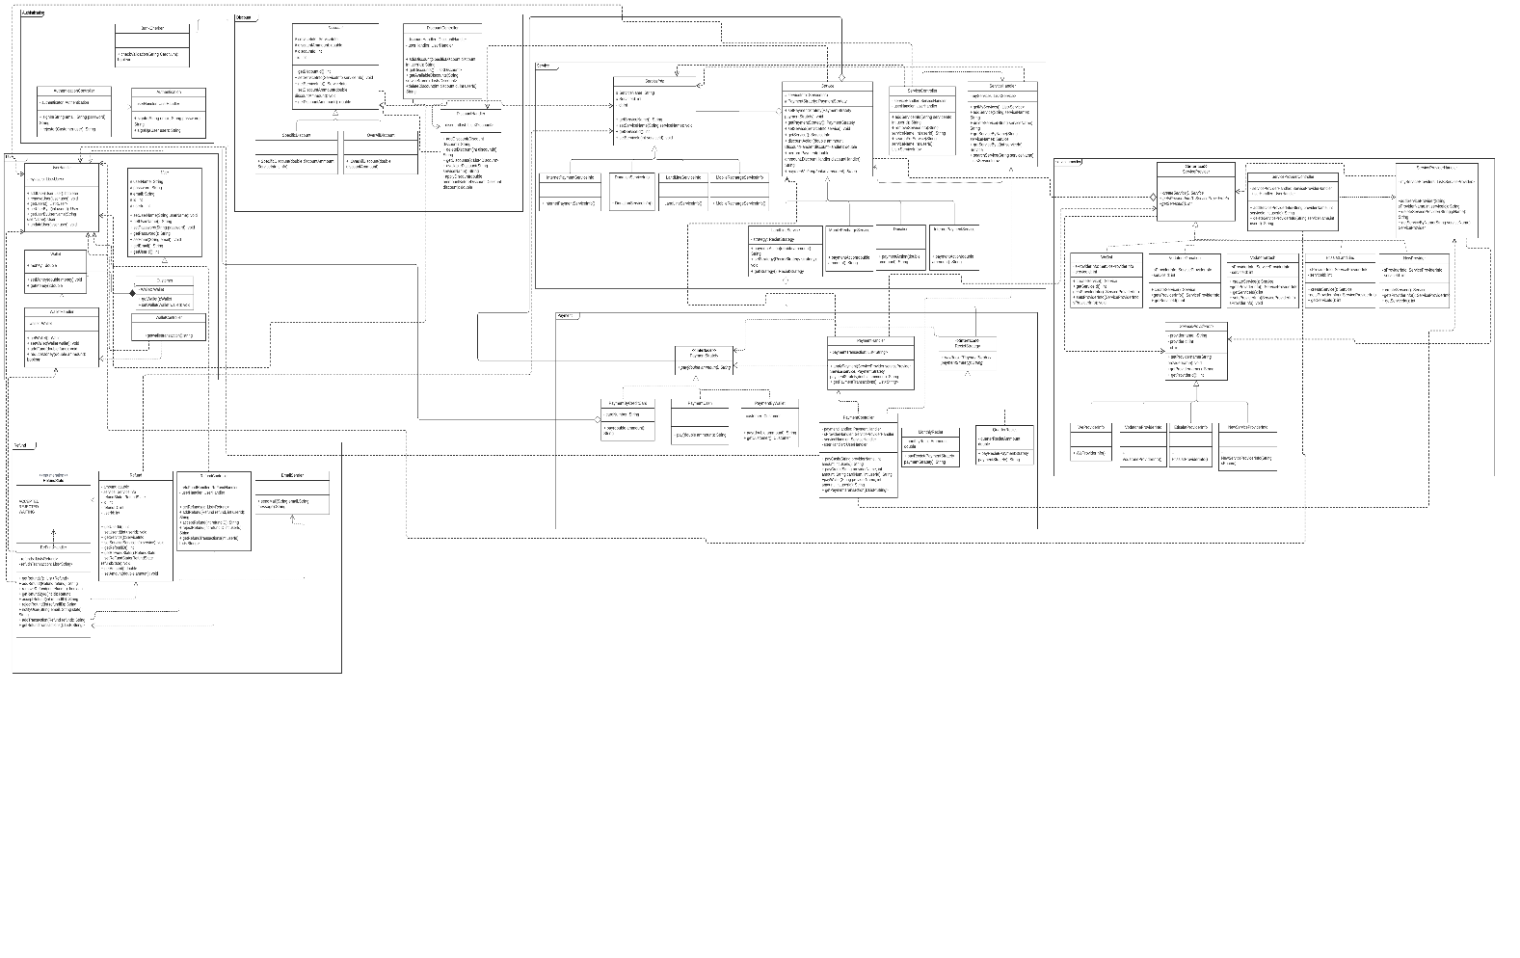

# I have added the picture for more observation in a folder of photos and this is the link to the diagram

# Link for class diagram

# [https://lucid.app/lucidchart/e7525835-965f-4813-b78e-f96a88a74411/edit?invitationId=inv_06e2e41e-56fa-4268-b5e9-6946c7cb5beb&page=HWEp-vi-RSFO#](https://lucid.app/lucidchart/e7525835-965f-4813-b78e-f96a88a74411/edit?invitationId=inv_06e2e41e-56fa-4268-b5e9-6946c7cb5beb&page=HWEp-vi-RSFO)

# Class diagram Explanation

|  |  |  |
| --- | --- | --- |
| **Design Pattern** | **Justification** | **Related Classes** |
| Strategy Pattern | Each payment method and The Recite strategy of landline service have different Algorithm | Payment Strategy  Payment by wallet  Payment by cash  Payment by credit card  Landline strategy  Monthly recipe  Quarter Recite |
| Factory Pattern | Each service provider can create a specific service like Vodafone cash can a create mobile recharge service | Service (product)  Mobile recharge service  Donation  Landline service  Internet payment seethe service  Service provider (creator)  Vodafone cash  We dal  Etisalat landline  Donation Factory |
| Template Pattern | template method "perform payment" is considered an algorithm with fixed steps  1 discount action 2 payment action  discount action is concrete and payment action is abstract that each service implements it | Service  Mobile recharge service  Donation  Internet payment service  Landline service |

# Sequence diagram design

# Sign in

# Sign up

# Search for Service

**Payment**

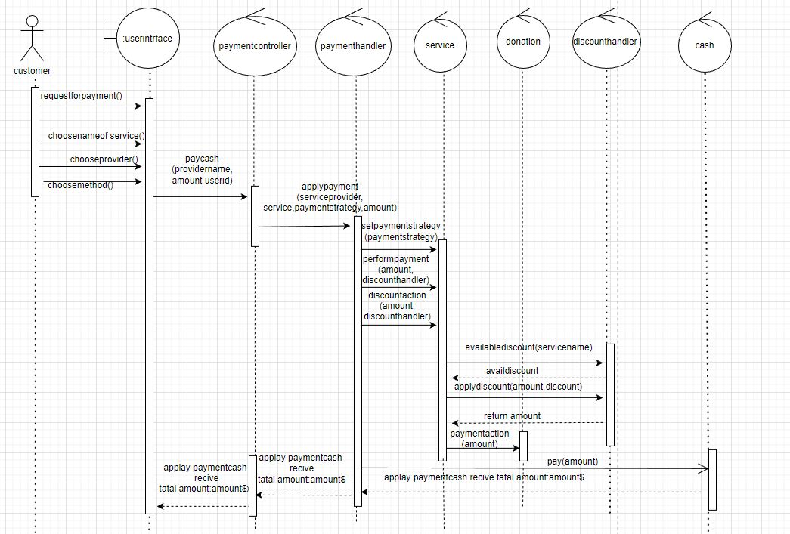

# Add Refund

**Check Discount**

# Add Discount

# Accept Refund

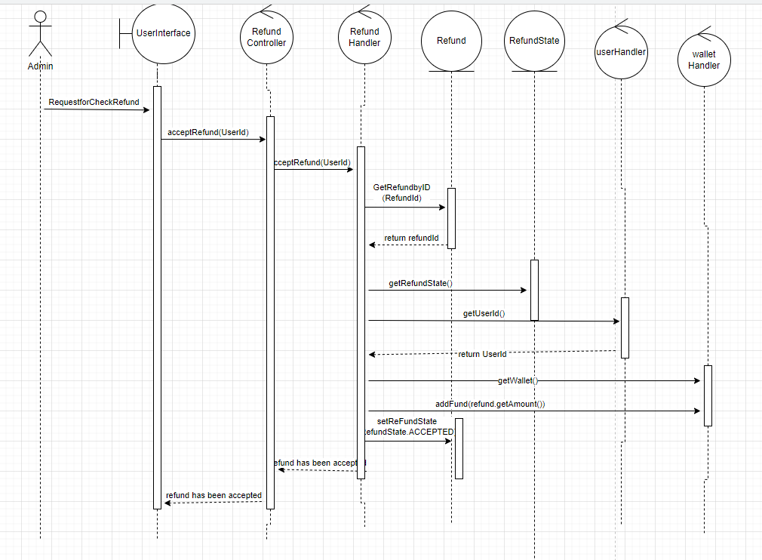

# Sub System Decomposition

# Requirements Exposure as Web Service API

**Part 1: Exposed Postman Collection**

[**https://www.postman.com/planetary-moon-217757/workspace/softwareproject/collection/25069920-96d9eef3-f697-451c-b7b2-50a958549e6c?action=share&creator=25069920**](https://www.postman.com/planetary-moon-217757/workspace/softwareproject/collection/25069920-96d9eef3-f697-451c-b7b2-50a958549e6c?action=share&creator=25069920)

**b**

**Part 2:**

**Explain here the exact mapping between every single requirement and its corresponding web service API operation. A sample example is provided to better explain the concept.**

|  |  |  |
| --- | --- | --- |
| Requirement |  | Exposed API |
| The system should check if the username or the email is registered before |  | post/http://localhost:8080/rejester?=&  The service checks if the user exists or not and the service returns a message that describes the sign up attempt if it was successful or unsuccessfully. |
| The user should be able to sign-in to the system. Given the user’s email and apassword, the user can login to the system |  | Get/http://localhost:8080/sign-in/mah@gmail/0123The API takes e-mail and password as parameters in url queryThe service return if the user exists or not in a string returntype. |
| the user should be able to search for a service |  | Get/http://localhost:8080/service/Mobile/1 this service takes service name of string type and returns the existed service |
| the admin should add new service provider to the system |  | post/http://localhost:8080/provider/Torrent/1/1 this service should take provider name , service id which the provider supports this service and takes user ID for authentication  it returns provider added or failed to add or services doen not exist depending on the situation |
| the admin should be able to add specific discounts on specific services |  | post/http://localhost:8080/discount/1 this service takes discount amount and user ID and checks if the user is new user or existing one to check if the user is provided one or more discount , and it returns string of diicount adding status |
| the user should be able to check if there is a discount added on a service or not |  | Get/http://localhost:8080/discount/InternetPayment/1 this service takes service name , user ID to check if there are available discounts to retrieve and it returns list of available discount if exists on this service |
| the user should be able to request a refund add request to a service |  | post/http://localhost:8080/refund/1 this service should take user ID and refund object to request a refund formed from the user and it returns message shows that the request is added |
| the admin should be able to approve the refund requests given by the user |  | Put/http://localhost:8080/refund/accept/1/1 this service takes refund ID and user ID to approve the request of the user to accept the refund request and put money back to wallet and it returns success message of accepting the refund request |
| the user should be able to list all his/her refund transactions |  | Get/http://localhost:8080/refund/trans/1 this service should take user ID and returns a list of all the users' refund transactions |
| the user should be able to pay for a service cash |  | Get/http://localhost:8080/cash/Vodafone/120/1 this service should take provider name , amount , user ID and checks the provider name and user ID exists or not and returns status of the payment method |
| the user should be able to pay for the service using credit card |  | Get/http://localhost:8080/credit/We/120/147852/1 this service should take provider name , amount , card number , and user ID and checks the provider name and user ID exists or not and returns status of the payment method and apply payment in credit card |
| the user should be able to pay for a service using the wallet in the system |  | Get/http://localhost:8080/wallet/We/120/1 this service should take provider name , amount , and user ID and it takes the requested amount from the wallet after authenticating the user ID to pay for the requested service |
| the user should be able to list his wallet transactions |  | Get/http://localhost:8080/wallet/trans/1 this service should take userID and list the transactions that are done using the wallet |
|  |  |  |

# GitHub repository link

<https://github.com/MahmoudSayedA/software-project>